EXERCISE-14

14.Design PDA using simulator to accept the input string anb2n

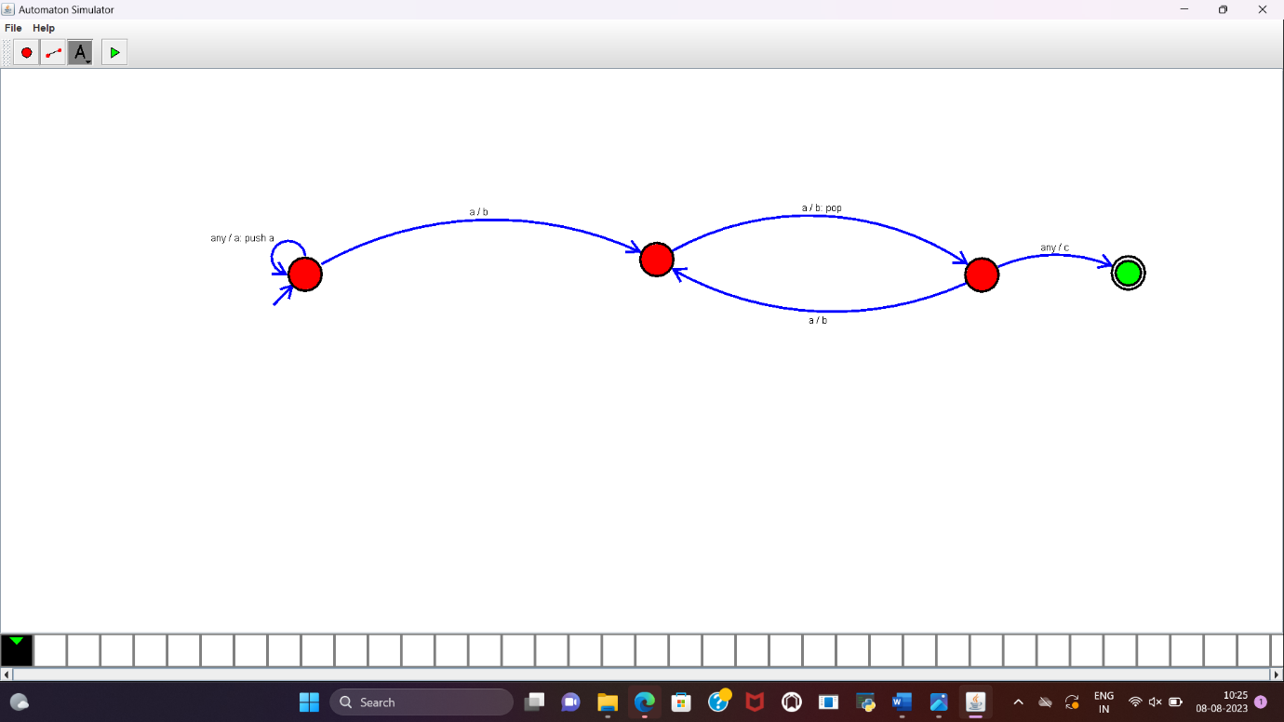

RESULT:

PDA to accept the string a^nb^2n is designed and implemented successfully.